

State-approved Curriculum

Nurse Aide I Training Program

MODULE J

Nutrition and Fluids

Teaching Guide

2024 Version 1.2





DN.C. DivisionHof Health SService RRegulation

North Carolina Department of Health and Human Services

Division of Health Service Regulation

North Carolina Education and Credentialing Section

NCDHHS is an equal opportunity employer.

Module J – Nutrition and Fluids

**Teaching Guide**

**Objectives**

1. Describe OBRA requirements for serving food
2. Identify basic nutrients
3. Explain the use of MyPlate
4. Describe special diets, fluid balance and imbalance
5. Discuss medical conditions and precautions related to nutrition and fluid intake
6. Identify dietary practices of various religions

**Advance Preparation – In General**

* Review curriculum and presentation materials
* Add examples or comments to Notes Section
* Set up computer/projector
* Establish internet connection

**Supplies**

* 1 sheet of construction paper or half-sheets of poster paper and 2 or 3 markers per each group of students (Activity #J23)

**Handouts** – Duplicate one copy each per student.

* **#J18 What’s On Your Plate?**
* **#J23 Therapeutic (Modified) Diets**

**Instructional Resources/Guest Speakers – Optional**

**Advance Preparation – Teaching Tips**

* **#J5** Good nutrition examples, management of common diseasesand characteristics
* **#J18 -1 Web site:** Familiarize self with the following Web site: [www.choosemyplate.gov](http://www.choosemyplate.gov)
* **#J18 Video Opportunities:** Do a video search of a *ChooseMyPlate* using your favorite search engine and decide whether you would like to show a video as a supplement.
* **#J33** To explore further dietary practices due to cultural and religious influences refer to website: [Strategize and Act | FSG Toolkit | CDC](https://www.cdc.gov/food-service-guidelines-toolkit/php/strategize-act/)

**Advance Preparation – Activities**

* **#J18 Choose MyPlate:** Familiarize self with the following Web site: [www.choosemyplate.gov](http://www.choosemyplate.gov)

Duplicate a copy of the activity sheet for each student. Print the document on the landscape setting on the print instructions. What’s on your plate? Ask students to take the quizzes on this website: <https://www.choosemyplate.gov/quiz>

* **#J23 Therapeutic (Modified) Diets Project:** Distribute #J23 Therapeutic (Modified) Diets handout. Place students in groups of 2 or 3. Assign a special diet from the handout to each group and have them present to the entire class.

For each of the different diets, each group should discuss the following for the assigned diet:

* Description
* Uses
* Foods allowed or not allowed

Provide each group with a sheet of construction paper or a half-sheet of poster paper, and 2 or 3 markers to create a poster to use during presentation.

Require each group to select a team leader, who facilitates the process within the group, and a reporter, who holds up and explains the poster to the class during the presentation.

Module J – Nutrition

**Definition List**

**Advancing a diet** – food is gradually reintroduced to the resident due to surgery, in preparation for a procedure, or illness

**Aspiration** – accidental breathing in of food, fluid, vomit, or other object into lungs

**Calcium** – a mineral that keep bones and teeth strong

**Calorie** – energy value of a food or a beverage

**Carbohydrates** – a nutrient that supplies energy and helps body use fats

**Dehydration** – serious situation when a person does not take in enough fluid for the body causing a decrease in amount of water in tissue

**Dysphagia** – difficulty swallowing

**Fats** – a nutrient that is a good source of energy and gives flavor to food

**Fluid Balance** – when fluids taken in equal the fluids eliminated

**Force Fluids** – medical order for person to drink more fluids

**Intake** – amount of fluids taken in each day

**Iron** – a mineral that helps blood carry oxygen to all parts of the body

**Malnutrition** – refers to deficiencies, excesses, or imbalances in a person’s intake of energy and/or nutrients.

**Minerals** – a nutrient that helps the body function normally

**NPO** – nothing by mouth

**Nutrients** – substance found in food and fluids that are used by body for growth and maintenance of health

**Nutrition** – when the body takes in and uses foods and fluids to maintain health

**Nutrition Facts Label** – simple tool from Food and Drug Administration (FDA) found on all packaged foods and beverages and serves as a guide for making choices that can affect health

**Output** – amount of fluids eliminated each day

**Proteins** – a nutrient that is needed by every cell to help grow new tissue and help with tissue repair

**Restrict Fluids** – medical order for person to limit fluids taken in

**Special Diet (therapeutic diet or modified diet)** – a specific diet ordered for a person because of illness, condition, or preparation for a procedure

**Serving Amount** – shows the amount that is equal to one serving of a food or beverage

**Serving Size** – shows the number of servings in a package or container of food or beverage

**Vitamins** – a nutrient that helps the body function normally; body gets majority of vitamins from certain foods; examples are Vitamins A and C

| Module J – Nutrition and Fluids | |
| --- | --- |
| **(S-1) Title Slide** | |
| **(S-2) Objectives**   1. Describe OBRA requirements for serving food 2. Identify basic nutrients 3. Explain the use of MyPlate 4. Describe special diets, fluid balance and imbalance 5. Discuss medical conditions and precautions related to nutrition and fluid intake 6. Identify dietary practices of various religions | |
| **(S-3) OBRA Dietary Requirements –** **Nursing Homes (1)**  OBRA requires the following for each resident:   * Dietary and nutritional needs are met * Diet is nourishing, well-balanced, and tastes good * Meals are provided at least 3 times a day, and a snack is offered at bedtime * Food preferences are offered and substituted if food served is refused * Assistive devices and utensils are provided as needed | **Notes:** |
| **(S-4) OBRA Dietary Requirements –** **Nursing Homes (1)**  OBRA requirements for meals:   * Appetizing, smells and looks good * Varied in color and texture * Served at the correct temperature * Served promptly * Prepared to meet individual needs | **Notes:** |
| **(S-5) Nutrition**  When the body takes uses foods and fluids to:   * Promote physical and mental health * Increase resistance to illness * Produce energy and vitality * Aid in healing * Assist one to feel and sleep better and help avoid or manage common diseases * Helps avoid or manage common diseases (Cancers, Type 2 diabetes, heart disease, high blood pressure, obesity, and osteoporosis. * Characteristics of a healthy diet: * Well-developed, healthy body, at the appropriate weight * Alert facial expression * Healthy, shiny hair * Clear skin and bright eyes * Healthy appetite * Regular elimination habits * Restful sleep patterns | **Notes:** |
| **(S-6) Characteristics of Poor Nutrition (Malnutrition)**  Malnutrition refers to deficiencies, excesses, or imbalances in a person’s intake of energy and/or nutrients.   * Changes in weight * Poor skin color and appearance * Dull looking hair, eyes, and skin * Irregular elimination habits * Poor sleep patterns * Abnormal conditions, such as osteoporosis or anemia * Tired | **Notes:** |
| **(S-7) Age-Related Changes Affecting Nutrition**   * Need for fewer calories * Vitamin and mineral requirements change * Drugs may affect how nutrients are absorbed and used * Teeth/dentures affect ability to chew food * Saliva and gastric juices decrease * Appetite and thirst decrease * Constipation may occur * Taste and smell diminish * May require assistance with dining | **Notes:** |
| **(S-8) Nutrients**   * Water * Fats * Carbohydrates * Proteins * Vitamins * Minerals | **Notes:** |
| **(S-9) Water**   * Most essential nutrient * Needed for every cell in body * Main part of the blood * Importance to body * Helps move oxygen and nutrients into cells and removes waste products out of cells * Helps with digestion and absorption of food * Helps maintain temperature by perspiration * Water is essential for survival | **Notes:** |
| **(S-10) Fats**   * A good source of energy * Gives flavor to food * Important for the absorption of certain vitamins * Sources of fat include butter, oil, and fatty meat * Plant-based dietary sources of fat include olives, nuts, and seeds * Certain fats may increase cholesterol levels and lead to heart disease | **Notes:** |
| **(S-11) Carbohydrates**   * Supplies energy and helps body use fats * Sources of carbohydrates: * Breads * Fruits * Candy * Sugary soft drinks * Certain carbohydrates add fiber to diet that help with elimination | **Notes:** |
| **(S-12) Protein**  Needed by every cell to help grow new tissue and help with tissue repair   * Sources of proteins are meats, cheese, beans, and dairy | **Notes:** |
| **(S-13) Vitamins**   * Help the body function normally * Body gets vitamins from each of the food groups * 13 essential vitamins * Vitamin – A, C, D, E, K, and the B vitamins (thiamine riboflavin, niacin, pantothenic acid, biotin, folate, B6 and B12) | **Notes:** |
| **(S-14) Minerals**   * Help the body function normally * Calcium keeps bones and teeth strong * Iron helps blood carry oxygen to all parts of the body | **Notes:** |
| **(S-15) Calories**   * Energy value of a food or beverage * Number of calories in one serving size | **Notes:** |
| **(S-16) Serving Size**   * Serving sizes are given in familiar measurements (cups, slices, or pieces) * Information on the nutrition label is based on one serving of the food or beverage * Label shows the number of servings in the package or container * Be aware of consumption | **Notes:** |
| **(S-17) Serving Size Using Common Objects**   * Deck of Cards * 3 ounces of meat, poultry, or fish * Baseball * 1 cup rice, fruit, veggies, cereal, or pasta * Tennis Ball * 1 medium sized fruit * Postage Stamp * Stick of butter sliced | **Notes:** |
| **(S-18) USDA’s MyPlate**   * Developed by U.S. Department of Agriculture * It recommends balancing the intake of healthy food choices and physical activity * Designed to help people easily build a healthy plate during meal times * Shows the amounts of each food group that should be on a person’s plate during meals * Emphasizes vegetables, fruits, grains, protein, and low-fat dairy * Advocates drinking water instead of sugary drinks * Make half your plate fruits and vegetables * Choose a variety of colored vegetables * Choose whole fruits – fresh, frozen, dried, or canned in 100% juice * Make half your grains whole grains * Choose low-fat or fat-free milk or yogurt * Mix up your protein foods to include seafood, beans and peas, unsalted nuts and seeds, soy products, eggs, and lean meats and poultry   **Teaching Tip:**  **#J18 -1 Web site:** Familiarize self with the following Web site: [www.choosemyplate.gov](http://www.choosemyplate.gov)  **#J18 -2 Video Opportunities** **(optional):** Do a video search of a *ChooseMyPlate* using your favorite search engine and decide whether you would like to show a video as a supplement.  **Activity:**  **#J18 Choose MyPlate:** Duplicate a copy of the activity sheet for each student. Print the document on the landscape setting on the print instructions. What’s on your plate?  Ask students to take the quizzes on this website: <https://www.choosemyplate.gov/quiz> | **Notes:** |
| **(S-19) Providing Water for Residents**   * Residents need fresh drinking water * Before providing water, check with care plan or nurse * Follow facility’s procedure regarding time schedule and process * Ensure resident’s name and room number are labeled on ice pitcher * Make sure water pitcher and cup are clean. Check for cracks and chips. * Never touch inside or rim of cup and pitcher * Always place ice into the water pitcher first * Never take resident’s used water pitcher to ice machine * Never scoop ice with water pitcher | **Notes:** |
| **(S-20) The Diet Card**   * Prepared by dietary department based on doctor’s order * Each resident’s meal has its own diet card * At a minimum, lists the resident’s room number, name, type of diet and food allergies * The nurse aide who delivers the meal tray must verify that the right resident is receiving the right meal tray, with the right diet on it | **Notes:** |
| **(S-21) Regular Diet**   * Ordered by the doctor * A basic, well-balanced diet * Without limits or restrictions | **Notes:** |
| **(S-22) Advance Diet**   * Food is gradually reintroduced to the resident * Post surgery or a specific medical condition * Resident may start out NPO (nothing by mouth) > ice chips > clear liquids > full liquids > mechanical soft > regular diet | **Notes:** |
| **(S-23)** **Special Diets**   * Therapeutic or modified diet * Ordered by the doctor and planned by dietician with input from resident * May restrict or eliminate certain foods or fluids, based on illness, in preparation for procedures, or to meet nutritional needs   **ACTIVITY #J23: Therapeutic (Modified) Diets Project**  Distribute **#J23: Therapeutic (Modified) Diets** handout. Place students in groups of 2 or 3.  Assign a special diet from the handout to each group and have them present to the entire class.  For each of the different diets, each group should discuss the following for the assigned diet:   * Description * Uses * Foods allowed or not allowed   Provide each group with a sheet of construction paper or a half-sheet of poster paper, and 2 or 3 markers to create a poster to use during presentation.  Require each group to select a team leader, who facilitates the process within the group, and a reporter, who holds up and explains the poster to the class during the presentation. | **Notes:** |
| **(S-24) Other Forms of Nourishment**   * Residents may be unable to eat due to illness, surgery, or injury * Intravenous (IV) fluids feed the resident through a vein * Parenteral nutrition is the intravenous infusion of nutrients administered directly into the bloodstream, bypassing the digestive system. * Enteral nutrition feeds the resident through a feeding tube into the gastrointestinal track * Nasogastric tube provides nourishment through the nose and directly into the stomach. Gastrostomy tube provides nourishment into the stomach through the abdomen. * The nurse aide * Observes for and reports redness, swelling, or pain at the site * Reports low supply of fluid in bag * Must be careful with tubing and connections when providing care | **Notes:** |
| **(S-25) Alternative and Supplemental Nutrients**   * Ordered by physician and to serve, as between meals * Given when a resident needs extra protein, calories, and fluids * Supplemental nourishment includes: * Protein supplements, pudding, ice cream, milkshake * Nurse aide’s role is to:   + Assist the resident as needed   + Report amount resident ate or drank | **Notes:** |
| **(S-26) Assisting the Resident with Meals (1)**  *Refer to Module Z Threads of Care (Assisting with Dining/Feeding Resident and Measuring and Recording Intake)*   * When a resident pockets food in cheeks: * Remind resident to chew and swallow * Touch cheek * Ask the resident to use his tongue to move the food * Holds food in mouth: * Ask resident to chew and swallow * Make sure resident has swallowed before offering more food. * The nurse aide should: * Use assistive devices as ordered. * Use short, clear verbal cues * Be aware of signs of aspiration * Aspiration is the accidental breathing in of food, fluid, vomit, or other object into lungs   + Can cause pneumonia or death * Nurse aide’s role in preventing aspiration * Place resident in upright position at 90-degree angle for eating and drinking, and at least 30 minutes afterward * Feed slowly * Avoid distractions * Offer small amounts of food * Offer bite of food, then sip of liquid, repeat * If one side is paralyzed, place food in non-paralyzed side of the mouth * Make sure food is swallowed after each bite before next bite/sip * Provide mouth care after meals * Report signs of aspiration immediately – gagging, vomiting, clutching throat (classic sign of choking), cyanosis, shortness of breath or difficulty breathing; unconsciousness, complaints of chest pain or chest tightness * Provide thickened liquids, per directive from nurse | **Notes:** |
| **(S-27) Assisting the Resident with Meals (2)**   * For visually-impaired residents:   + Read menus as needed   + Use an imaginary clock face to explain position of food on plate * For residents who had stroke (CVA):   + Place food on the unaffected or stronger side of mouth   + Make sure food is swallowed   + Place food in resident’s field of vision * The nurse aide should be aware of precautions regarding dysphagia. Dysphagia is difficulty in swallowing, and it poses a danger of aspiration * The causes of dysphagia include: * Illness, such as stroke * Some medicines * Problems with mouth and throat muscles * Weakness * Problems with teeth or dentures * Signs/symptoms of dysphagia: * Generally, eats very slowly, frequent throat clearing, “ahem,” and decrease in appetite * Avoids eating and certain textured foods * When eating/drinking, the resident vomits or chokes, has problems with breathing, eyes water, spits out food pieces, has difficulty with chewing, has difficulty swallowing small pieces of food (or pills), suddenly spits out food, and has to swallow several times when eating a single bite of food * During/after meals, the resident drools or dribbles food or fluid from mouth, pockets or keeps food inside mouth or cheeks, coughs, gurgles when talking, and food/fluid comes up, into or out of the nose * Complaints of heartburn, food getting stuck, and hoarseness after eating | **Notes:** |
| **(S-28) Fluid Balance**   * Amount of fluid taken in (intake) equals the amount of fluid lost (output) * Needed to survive and for good health * Take in water by drinking fluids and eating foods * Lose water through urine, feces, vomit, perspiration, breathing out, drainage from wounds and suctioning of liquids from stomach * Death can occur if the body has too much or too little water in the tissues | **Notes:** |
| **(S-29) Measuring Intake and Output (I&O)**   * Fluid intake reflects nutritional status * Measurement of fluid intake helps prevent or detect complications * Nurse aide expected to monitor and document special fluid orders * Medical treatment is planned and evaluated based on results * Evaluates fluid balance * Evaluates kidney function | **Notes:** |
| **(S-30) Special Fluid Orders**   * The doctor may order a specific amount and type of fluid a resident must drink a day to maintain fluid balance * Order is identified on the resident’s diet card   + Encourage fluids – increase fluids   + Restrict fluids – limit fluids   + Nothing by mouth (NPO) – no fluids or food   + Thickened liquids – all fluids are thickened * Nurse aide must measure and record intake very carefully   *Refer to Module Z Threads of Care (Measuring and Recording Urinary Output)* | **Notes:** |
| **(S-31) Dehydration**   * Occurs when fluid intake is less than fluid output * Body tissues are lacking in water * May occur from vomiting, diarrhea, fever, or refusing to drink fluids * Resident does not take in enough fluid for the body causing tissues to lack water * May occur with bleeding, dementia, fever, poor fluid intake, fluid restriction, excess sweating, vomiting, increase in urination, medicines | **Notes:** |
| **(S-32) Nurse Aide’s Role**   * Observe and report signs and symptoms of potential dehydration and presence of dehydration * Warning signs of potential for dehydration * Drinks less than six 8-ounce glasses of fluids per day * Drinks little or no fluids during meals * Needs help drinking fluids * Has trouble swallowing fluids * Has fever, vomiting, diarrhea * Confused * Complaints of thirst, dry mouth * Decrease in urinary output * Signs/symptoms of dehydration * Severe thirst * Dry mouth and mucous membranes * Cracked lips * Warm, dry, wrinkled skin * Sunken eyes * Flushed face * Dark, strong-smelling urine, in small amounts * Constipation * Weight loss * Weakness, dizziness, confusion * Headache * Irritable * Rapid, weak pulse * Irregular heartbeat * Low blood pressure * Determine preferences of fluids and offer * Assure water pitcher and cup are within reach * Offer assistance and use assistive devices if needed * Measure and record I & O accurately, if ordered * Force fluids (encourage to drink more fluids), if ordered by the doctor | **Notes:** |
| **(S-33) Food Preferences and Dietary Restrictions**  Culture and religion may influence dietary practices, food choices, and food preparation  **TEACHING TIP #S33** To explore further dietary practices due to cultural and religious influences refer to website  [Strategize and Act | FSG Toolkit | CDC](https://www.cdc.gov/food-service-guidelines-toolkit/php/strategize-act/) | **Notes:** |

Handout 1: **Handout #J18 What’s on Your Plate?**

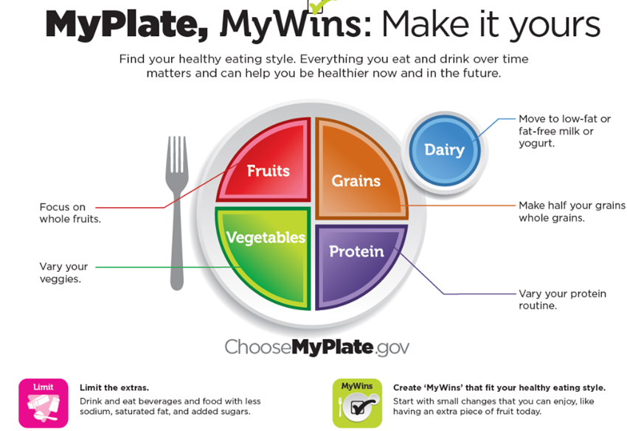

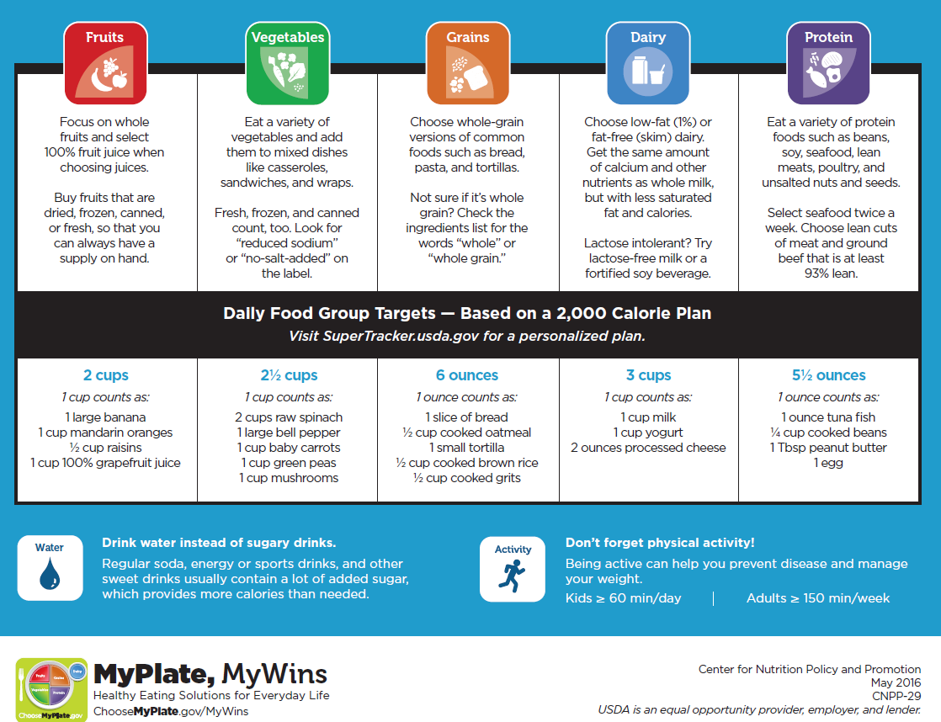

Handout #2: **Handout #J23 Therapeutic (Modified) Diets**

| **Type of Diet** | **Description** | **Purpose** | **Foods Allowed or Not Allowed** |
| --- | --- | --- | --- |
| **Clear Liquids** | Can see through, non-irritating, non-gassy | Post-operative, acute illness, infection, nausea/vomiting, prepare for GI procedures | Water, tea, black coffee, carbonated drinks, gelatin, clear fruit juices (apple, grape, cranberry) and clear broth |
| **Full Liquids** | All liquids | Next step after clear liquids, fever, nausea/ vomiting, resident unable to chew/swallow/digest solid foods | All clear liquids, plus custard, strained soups, strained fruit/ vegetable juices, milk, milk shakes, strained cooked cereal, plain ice-cream, sherbet, pudding, yogurt, popsicles |
| **Mechanical Soft** | Semi-solids, easily digested | Next step after full liquids, fever, nausea/ vomiting, resident unable to chew/swallow/digest solid foods | all liquids, plus non-fried eggs, non-fried meat/fish/poultry, mild cheeses, strained fruit juices, non-crusted breads, cooked cereal, cooked/pureed vegetables, cooked/canned non-seeded peeled fruits, plain cookies/cakes without nuts or fruit |
| **Fiber Restricted** | Leaves little residue and fiber in colon | Colon diseases, diarrhea | Coffee, tea, milk, carbonated drinks, strained fruit juices, refined bread/crackers/pasta (white), rice, cottage/cream cheese, non-fried eggs, plain puddings/cakes, gelatin, custard, sherbet/ice cream, strained vegetable juices, cooked/canned non-seeded peeled fruits, non-fried potatoes, strained cooked vegetables,  **NO RAW FRUITS, OR VEGETABLES** |
| **High-Fiber** | Increases residue and fiber in colon, stimulates movement of food | Constipation, GI disorders | All fruits and vegetables, whole-wheat bread, whole-grain cereals/rice, fried foods, milk, cream, butter, cheese, meats |
| **Bland** | Non-irritating, low in roughage, moderate temperature, not spicy | Ulcers, gallbladder/some intestinal disorders, after abdominal surgery | Lean meats, non-fried foods, white bread, creamed/refined cereals, cream/cottage cheese, gelatin, plain pudding/cakes/cookies, eggs, butter/cream, canned non-seeded peeled fruits/vegetables, potatoes, pasta, rice, strained/soft, cooked carrots, creamed soups, **NO FRIED FOODS** |

|  |  |  |  |
| --- | --- | --- | --- |
| **Type of Diet** | **Description** | **Purpose** | **Foods Allowed or Not Allowed** |
| **Calorie-Restricted** | Promotes weight loss and lowers body fat | Weight loss | Choose low-fat, low-carbohydrate foods, and lean meats; avoid the following: butter, cream, rice, gravy, salad oils, noodles, cakes, pastries, carbonated/alcoholic drinks, candy, potato chips, and similar foods |
| **High-Calorie** | Calories increased to 3000 to 4000 daily | Weight gain, some thyroid problems | Increases in all foods, large amounts of regular diet, meals plus 3 in-between meal snacks |
| **High-Iron** | Foods high in iron | Anemia, blood loss, non-menopausal women | Liver and other meats from organs, lean meats, egg yolks, shellfish, dried fruits/beans, green leafy vegetables, lima beans, peanut better, enriched breads/cereals |
| **Low Cholesterol** | Fat controlled, foods low in fat and prepared without adding fat | Heart/gallbladder/liver/pancreatic disease, disorders of fat digestion | Fat-free (skim) milk, buttermilk, cottage cheese, gelatin, sherbet, fruit, baked/broiled/roasted meat/poultry/fish, fat free broth/soup, margarine, rice, pasta, breads, cereals, vegetables, potatoes |
| **High-Protein** | Promotes tissue healing | Burns, high fever, infection | Meat, milk, eggs, cheese, fish, poultry, breads/ cereals, green leafy vegetables |
| **Sodium-Controlled** | Sodium (salt) controlled | Heart/liver/some kidney diseases, fluid retention | Allowed: fruits/vegetables and unsalted butter; not allowed: highly salted foods and foods high in sodium, adding salt at the table; restricted: adding salt for seasoning while cooking |
| **Diabetic Diet** | Dependent upon individual needs, calories and carbohydrates carefully controlled, fats and proteins regulated | Diabetes | Right amounts and types of foods, at the right times, during mealtimes and snacks |

|  |  |  |  |
| --- | --- | --- | --- |
| **Gluten Free** | Free of gluten, which is a protein found in wheat, rye, and barley. | Celiac Disease | Avoid foods containing wheat flour, such as tortilla, crackers, breads, cakes, pastas, and cereals. Some sauces and dressings also contain wheat. Hot dogs, broth, candy, and medication may also contain gluten. |
| **Vegetarian Diets:**   * **Lacto-ovo** | Excludes all meats, fish, and poultry, but allows eggs and dairy products | Diabetes  Obesity  Religious reasons  Dislike of meat  Compassion for animals  Belief in nonviolence  Financial issues | Avoid meats, fish, and poultry. |
| **Vegetarian Diets:**   * **Lacto-vegetarian** | Excludes all meats, fish, poultry, and eggs, but allows dairy products. | Diabetes  Obesity  Religious reasons  Dislike of meat  Compassion for animals  Belief in nonviolence  Financial issues | Avoid meats, fish, poultry, and eggs. |
| **Vegetarian Diets:**   * **Vegan** | Excludes all meats, fish, poultry, eggs, and dairy products, along with all foods that are derived from animals. | Diabetes  Obesity  Religious reasons  Dislike of meat  Compassion for animals  Belief in nonviolence  Financial issues | Avoid all meats, fish, poultry, eggs, dairy products, and all foods that are derived from animals. |

What Nutrients Do – Why It Is Important

**Instructor Resource (Do Not Hand Out to Students)**

**Carbohydrates** – supplies energy and helps body use fats, important nutrient to observe with diabetics

**Protein** – needed for tissue growth and repair, important nutrient for residents who had surgery or have pressure ulcers

**Vitamins and Minerals (**Calcium keeps bones and teeth strong. Iron helps blood carry oxygen to all parts of the body.

Fiber assists with elimination. Sodium vital in fluid balance and function of nerves and muscles, important nutrient to observe with residents with high blood pressure)

**Fats** – good source of energy. A diet high in fat and cholesterol can lead to hardening of the arteries, which can cause stroke or heart attack.

|  |  |  |  |
| --- | --- | --- | --- |
| **Foods High in Fats**   * Meats * Butter, shortening, lard, oils * Milk * Cheese * Egg yolks * Nuts | **Foods Low in Fats**   * Skim milk * Cottage cheese * Lean meat, poultry, fish (baked) * Vegetables * Fruits | | **Foods High in Cholesterol (Hint: Comes from Animals)**   * Eggs * Liver, whole milk, dairy products * Butter, cream * Shrimp * Duck and goose |
| **Foods High in Salt (Sodium)**   * Processed foods – bacon, luncheon meats, hot dogs * Buttermilk and cheese * Condiments – mayonnaise, salad dressings, ketchup, mustard * Mexican foods * Sauces – soy, teriyaki, steak, barbecue * Soups – canned, packaged * Vegetable juices, canned vegetables, pickled vegetables * Salted snack foods – pretzels, corn chips, potato chips, crackers * Baked goods – biscuits, muffins, cake, cookies, pie | **Foods Low in Salt (Sodium)**   * Fruits * Vegetables * Unsalted butter | | **Foods High in Protein**   * Meats * Fish * Poultry * Eggs * Milk and milk products * Beans and peas * Nuts * Green leafy vegetables |
| **Foods High in Carbohydrates**   * Soft drinks, fruit juices * Vegetables * Fruits * Cereals, breads * Candy | | **Foods High in Calcium**   * Egg yolks * Milk and milk products * Beans and dried peas * Green leafy vegetables * Whole grains * Nuts | |
| **Foods High in Iron**   * Liver * Meat * Eggs * Beans and dried peas * Green leafy vegetables * Breads and cereals * Nuts | | **Foods High in Fiber**   * Whole grain bread, muffins, bagels * Bran cereals * Cooked cereal, such as oatmeal * Whole wheat pasta * Whole grains, such as corn, brown rice, barley * Fruits * Vegetables * Nuts, such as almonds | |

Activity #1: **Activity #J18**

